Weekend activities
Unit
4
Teenage life
1
bedroom • DVD • film • friends • hobby •
house • out • something • sport • zoo
Work with a partner. Write the words. Write one more activity for each verb.

sport

watching

a good film
in my bedroom

alone

a DVD chilling

… …
with friends

sport a hobby

my homework
doing
something with my family

shopping

going

to the zoo

out with my friends to my friend’s house

… …
p.65
SB

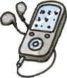What I like and what I don’t like
2
Look at the pictures and write John’s sentences about the weekend.

I like  I don’t like | doing listening going playing having | bowling. to music. a picnic.  my homework. the drums.

I like playing the drums.
- I like listening to music.
- I don’t like going bowling.
- I like having a picnic.
- I don’t like doing my homework.
p.65
SB

36 thirty-six

THEMES
1,2

4

3 Which words aren’t right?
Cross out the two things that aren’t right in each sentence!
- You can hoover your room / the grass / the house / your pocket money.
- You can tidy the chores / the living room / your desk/ your parents.
- You can fill / cut / empty/ cook the dishwasher.
- 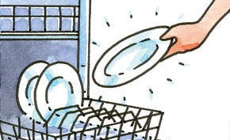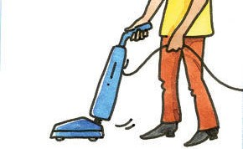You can do a paper round / the table / the chores / the kitchen.

p.67
SB

What chores do they do?
4
11
Listen to six people in Ellie’s class. What chores do
they do at home? Look at the pictures and draw lines. You will hear the recording twice.
TIPP

A B C
- Look at the pictures.
- Think: What are the chores in English?
- Then listen and do the exercise.

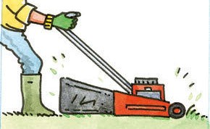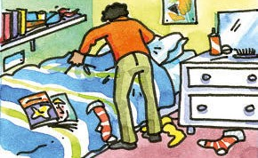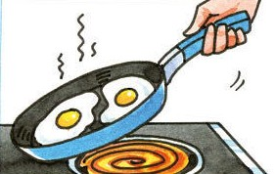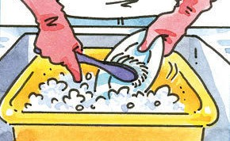
1 Sophie
2 John
3 Samantha
4 Olivia
5 Harry
6 James
D
E
F
G
p.67
SB

Chores in your house
5
Who does the chores in your house? Write at least four sentences.

I  My brother My sister My mum My dad | often sometimes always never | cook(s) the dinner. wash(es) up. cut(s) the grass.  …

I cut … He / She cuts …
I tidy … He / She tidies …
I empty …He / She empties … I wash …He / She washes …
TIPP

…
…
…
…
…
p.67
SB

thirty-seven 37

Next Sunday
4
THEMES
3
6
  - What are John’s plans for next Sunday? Write the sentences.

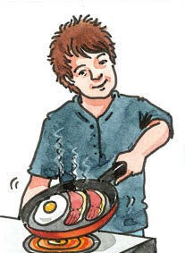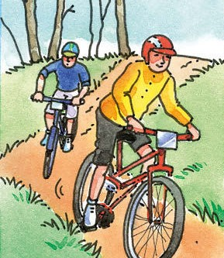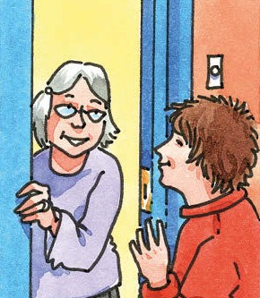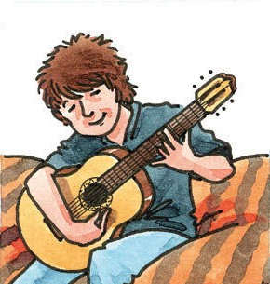
1
Next Sunday I’d like to …
2
Then I could …
3
In the afternoon
I want to …
4
In the evening
I’d like to …

Next Sunday I’d like to cook a big breakfast.
Then I could ride my bike with my friend. In the afternoon I want to visit my grandma. In the evening I’d like to play the guitar.

  - NOW YOU What are your plans for next Sunday?
Ideas:
cook … • do … • meet … • play … • see
… • visit … • watch … • work …
Write four sentences.

    - I’d like to …
    - I could …
    - Maybe I can …
    - I want to …
p.68
SB

Let’s meet!
7
about • free • idea • meet • sorry • you • your
- Complete the dialogue.

Partner A Let’s meet at the weekend!
Partner B Great idea . What about Friday evening?
Partner A Sorry , I’m busy Friday evening. What about Saturday morning? Partner B OK, I’m free then. Let’s meet at ten o’ clock at my house.
Partner A OK, ten o’ clock at your house. Partner B See you !
SB

- Read the dialogue with a partner. Then change the blue words and read it again.
p.69

38 thirty-eight

4
STORY 4

The new room
8
bike • bottle • CDs • CD player • chair • dog • dress • garage •
lamp • newspapers • sofa • table • wall • wardrobe
Look at the picture.
Label the things in the picture.

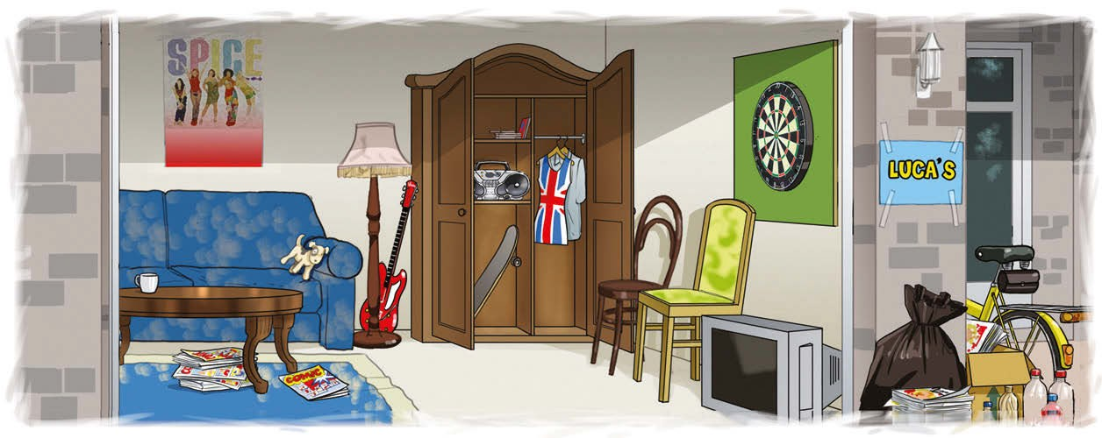
garage
sofa
dog
lamp
CDs
wardrobe
bike
wall
table
newspapers
CD player
chair
bottle
dress

p.71
SB

Tell the story.
9
Draw arrows and tell the story.

Luca didn’t
helped his dad in the garage. They found lots of old
have any money
for ice skating. He charity shop. Then they some things to a things. They took
liked the new room
They really
got money for the CDs at a second-hand shop. Luca put the
and had a 90s party.
they were surprised. his friends arrived garage. When
sofa back in the
p.71
SB

Who said what?
10
Look at the story again. Find the missing words. Then write who said these things.

- “I can do some chores.”

- “Tidy the garage and I’ll give you £5.”
- “It’s the messiest garage in Plymouth!”.
- “Can I have these old CDs, Dad?”
- “I’ll give you £20 for these other CDs.”
- “We’re going to go ice skating , Luca.”
- “I wore that dress in the 90s.”
Luca

Luca’s dad Luca Luca the woman (in the shop) Ellie Luca’s mum
p.71
SB

thirty-nine 39

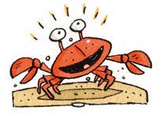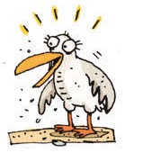
FOCUS
Comparisons (Vergleiche)
So kannst du Dinge oder Personen vergleichen:
Bei kurzen Adjektiven hängst du -er ans Ende des Adjektivs. Außerdem brauchst du noch das Wort than (= als):
A tennis ball is smaller than a football.
Bei einigen Adjektiven musst du bei der Schreibung aufpassen:
big bigger
hot hotter
noisy noisier friendly friendlier

Ellie wants to buy a toy for Finn.
11
  - Look at the picture and read the sentences. Find the right names for the teddy bears.

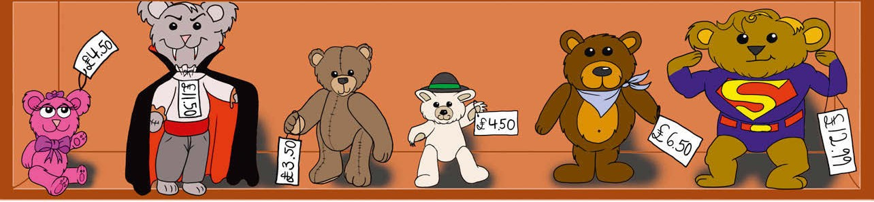

Cutie
Vlad
Teddy
Ted
Bob
Super-Ted

    - Teddy is cheaper than Ted.
    - Vlad is scarier than the others.
    - Vlad is a bit taller and cheaper than Super-Ted.
    - Bob is smaller than Super-Ted, but bigger than Ted.
    - Cutie is smaller and cuter than all the others.
  - Which teddy bear would you buy for Ellie’s baby brother?
SB

p.73

4
FOCUS ON LANGUAGE
5

Comparisons
12
a Finish the sentences.

- A car is faster (fast) than a bike.
- A city is bigger (big) than a town.
- January is colder (cold) than July in Germany.
- A magazine is cheaper (cheap) than a DVD.
- Tigers are bigger (big) than cats.

40 forty

A hamster is funnier than a monkey. OR A monkey is funnier than a hamster.
Aus -y am Ende eines Adjektivs wird -ie!
FOCUS ON LANGUAGE
4
TIPP
b What do you think?
Write sentences – say what you think.
1 funny – a hamster / a monkey
- scary – Dracula / Frankenstein

…
- healthy – orange juice / lemonade

…
- noisy– a city/ a village

…
- busy – London / Augsburg

…
p.73
Superlatives
Bei kurzen Adjektiven hängst du -est ans Ende des Adjektivs:
the greatest, the biggest, the funniest.
FOCUS
SB

Sam is bigger than the other boys.
13
Complete the sentences.

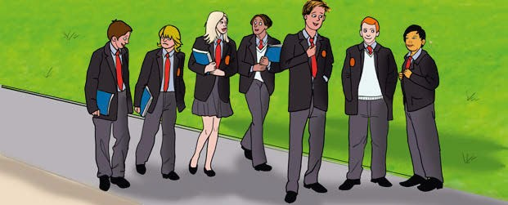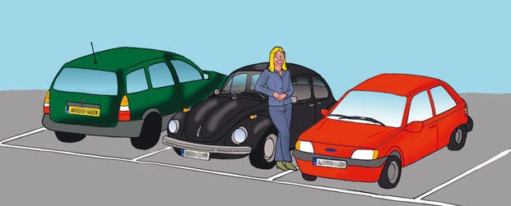
big
old

1 Sam is the biggest boy in the class. 2 The black car is the oldest car in the street.

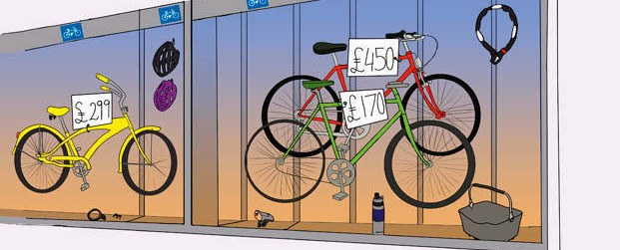
scary
cheap

3 Film 1 is the scariest film in
SB
4 The green bike is the cheapest

the cinema.
bike in the shop.
p.73

forty-one 41

Animal quiz
4
FOCUS ON LANGUAGE
14
Complete the questions with words from the box. Then do the quiz.
Answers on page 60.
TIPP

biggest • noisiest • oldest • slowest • smallest

- The noisiest animal in the world1 is the blue whale.2 You can hear it …
  - 8.5 km away.
  - 85 km away.

  - 850 km away.
✓

- 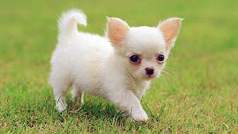The world’s smallest dog is only …
  - 10 cm tall.
✓

  - 15 cm tall.
  - 20 cm tall.

- The world’s biggest animal weighs3 more than 100 tonnes. What is it?

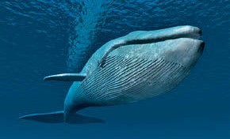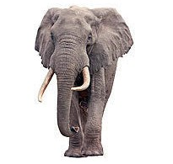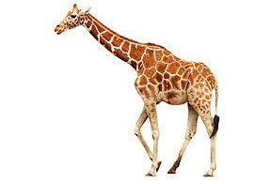

  - the blue whale b) the elephant c) the giraffe
✓

- The world’s slowest animal is …

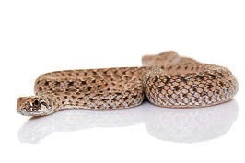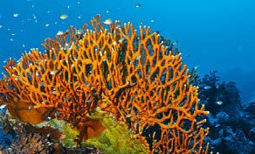

  - the snake b) the snail. Some snails need over 21 hours to go 1 km.
c) the coral – yes, it’s an animal!

- The oldest animal in the world is …
✓

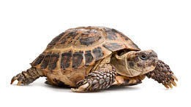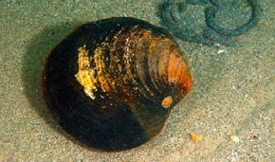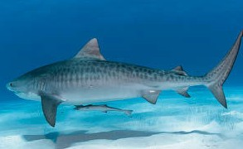

  - the tortoise. Some of them are 150 years old.
  - the Ocean Quahog4. c) the fish.

p.73
✓
SB

1 world Welt 2 blue whale Blauwal 3 weigh wiegen 4 Ocean Quahog Islandmuschel

42 forty-two

SKILLS TRAINING
6,7

4

What’s your hobby?
15
LISTENING
12
Listen to two teenagers. Circle the right option.

 | Lexi | Jacob
Hobby | pony riding / reading | internet / cooking
Started when? | 10 years / 12 years | 8 years / 11 years
When? | often / not very often | in the evening / every Sunday
Who with? | alone / with friends | with friends / with his dad
Where? | at home / 50 minutes away | in the kitchen / in his room
Why? | dangerous / great | likes nice food / loves computers

Emma’s talk Emma is in Mia’s class. Read her talk. Write the missing sentences.
16
GIVING A TALK
SB
p.76

I want to show you some photos. • That’s the end of my talk. •
I love their music and they’re really cool! • Today I’d like to talk about music. •
Do you have any questions? • Thank you for listening.

Emma Today I’d like to talk about music.
I love listening to music in my room – alone or with friends.

I want to show you some photos.
This is a photo of my favourite band – The Forest. They’re from London. I have all their CDs.
Why do I like them?

I love their music and they’re really cool!
There are three people in the group. The singer’s name is Fee. I think she’s really nice. Mel plays the guitar and Joe plays the drums.

Do you have any questions?
Mia Yes – I have a question. Do you go to concerts?
Emma Yes, sometimes. I saw The Forest last May – they were great!

That’s the end of my talk. Thank you for listening.
p.76
SB

forty-three 43

An email about a hobby
4
SKILLS TRAINING
17
WRITING
- Read this email from Jimmy, an English friend.

My hobby
Hi,
My hobby is doing stuff on the internet.
I have a laptop. I take it with me, so I can do my hobby at home, at school or when I’m on the bus. I often do stuff on the Internet after my homework. I do my hobby alone – but I often chat with friends in other countries! It’s fun, because I find out lots of interesting things about films and music. And I like getting ideas from other people.
Can you tell me about your hobby? – When / Where do you do it? Who with? Why do you like it? Jimmy

- Now write an email to Jimmy.
Du kannst über dein wirkliches Hobby schreiben oder etwas erfinden!
TIPP
Answer his yellow questions. Write at least 40 words.
Answer his yellow and green questions. Write at least 50 words.

- Look at your partner’s email.
You are the teacher! Tick (✓) “Yes” or “No” in the table.
- Anrede:
– Hi / Hello / Dear …
…
…
…
…
…
…
…
…

- Find a good start!
- When and where do you do your hobby?
- Who with?
- Why do you like it?
- Schluss:
Best wishes / Kind regards / All the best!
- Is your email at least 40 words?
50 words?

p.77
SB
My partner’s email … |  | Yes | No
1 | has a good start.
2 | says where he / she does the hobby.
3 | says when he / she does the hobby.
4 | says with who he / she does the hobby.
5 | says why he / she likes the hobby.

44 forty-four

SKILLS TRAINING 4

What’s on TV today?
18
SPEAKING
cartoon • comedy show • crime series • film •
music show • quiz show • reality show • soap (2x)
- sports show • talk show (2x)
Partner B: Go to page 46.

Partner A:
- Look at the list of TV programmes for BBC 1. Write what kind of TV programmes they are. You don’t need all the words in the green box.

 | BBC 1 |  | ITV 1
 | 19.00 Pointless  A quiz with a difference – who gets the least points? Presented by Alexander Armstrong.  quiz show |  | 19.00  soap
 | 19.30 Wanted Down Under  A British family lives in Australia for a week. The question is: will they want to stay there?  reality show |  | 19.30  soap
 | 20.00 The Graham Norton Show  Graham Norton talks with stars Hugh Grant, Jo Brand, Joanna Page and David Guetta.  talk show |  | 20.00  comedy show
 | 21.00 Lewis  An actor dies at the theatre. Who is the killer? Another mystery for Inspector Lewis.  crime series |  | 21.00  talk show
 | 22.00 Match of the Day  Join Gary Lineker for the best of the Premier League football action.  sports show |  | 22.00  film

- Ask your partner about the kind of programmes from 7 pm to 10 pm on ITV 1.
Write the answers in the ITV 1 list.

You What’s on ITV 1 at 7 pm?
Partner There’s a …
You And at 7.30?
…
- Answer your partner’s questions about the kind of programmes on BBC 1.
- Now agree on what you and your partner can watch together.
You At 7 pm there’s a quiz show and a soap.
Partner Let’s watch the soap.
You OK./ No, I don’t like soaps. Let’s watch the quiz show.
Partner OK. What about at 7.30? There’s a …

p.78
SB

forty-five 45

18

PARTNER B:
SPEAKING
What’s on TV today?

  - Look at the list of TV programmes for ITV 1. Write what kind of TV programmes they are. You don’t need all the words in the green box.

 | BBC 1 | ITV 1
 | 19.00  quiz show | 19.00 Emmerdale  Sandy looks for somewhere to live. Debbie has a plan to win Andy’s love.  soap
 | 19.30  reality show | 19.30 Coronation Street  Tyrone sees his doctor – and gets bad news. Becky gets a shock at Danny’s house.  soap
 | 20.00  talk show | 20.00 You’ve Been Framed  Lots of funny videos – presented by comedian Harry Hill.  comedy show
 | 21.00  crime series | 21.00 The Jonathan Ross Show  Ross talks to stars Robin Williams and Elle Macpherson.  talk show
 | 22.00  sports show | 22.00 Jurassic Park  Spielberg’s classic dinosaur movie.  film

  - Answer your partners questions about the kind of programmes on ITV 1.
  - Ask your partner about the kind of programmes from 7 pm to 10 pm on BBC 1.
Write the answers in the BBC 1 list.

You What’s on BBC 1 at 7 pm?
Partner There’s a …
You And at 7.30?
…
  - Now agree on what you and your partner can watch together.
You At 7 pm there’s a quiz show and a soap.
Partner Let’s watch the soap.
You OK./ No, I don’t like soaps. Let’s watch the quiz show.
Partner OK. What about at 7.30? There’s a …

p.78
SB

4
SKILLS TRAINING
8
cartoon • comedy show • crime series • film •
music show • quiz show • reality show • soap (2x)
- sports show • talk show (2x)

46 forty-six

PORTFOLIO 4

Unit 4 hast du schon fast geschafft!
Hier kannst du noch einmal deinen Lernfortschritt überprüfen. Male die Ampellichter aus.
DFF

Ich kann sagen, wie ich zu Hause helfe.
1
- Nenne sechs Hausarbeiten und sage, ob du sie erledigst oder nicht. Lösungsbeispiel:
WB
4.2
S.37

- I tidy my room .
- I fill the dishwasher .
- I cook the dinner .
- I don’t wash up .

I don’t hoover my room .
- I don’t cut the grass .

Ich kann über meine Wochenendpläne sprechen und eine Verabredung treffen.
2
- Fülle die Lücken im Dialog.
4.3

S.38
DFF

You Let’s meet at the weekend. What about about Saturday afternoon? Your friend Sorry , I’m busy Saturday afternoon. What about Sunday afternoon? You OK, I’m free then. Let’s meet at four o’clock at my house. See you !
WB
DFF

Ich kann Dinge miteinander vergleichen.
3
- Stelle Vergleiche an und fülle die Lücken.
4.5

S.40–42
WB

1 | (fast) | A car is faster than a bike.
2 | (big) | An elephant is bigger than a cow.
3 | (cheap) | Camping is cheaper than staying in a hotel.

Ich kann mich über Hobbies unterhalten.
4
- Schau dir die Antworten an und ergänze die dazu passenden Fragen.
4.7

S.43
DFF

  - What’s your hobby? – Watching TV.
WB
  - When do you do it? – After school.
  - Where do you do it? – At home.
  - Who with? – Alone.

Why do you like it?

– I like it because I can chill out.

My English lessons – Unit 4
I like / I don't like these chores: My favourite hobbies are . Next weekend I'd like to .
My English is
GREAT!
OK
NOT SO GOOD

forty-seven 47

